The 3 stages of the CTF3

- Preliminary
- Initial
- Nominal
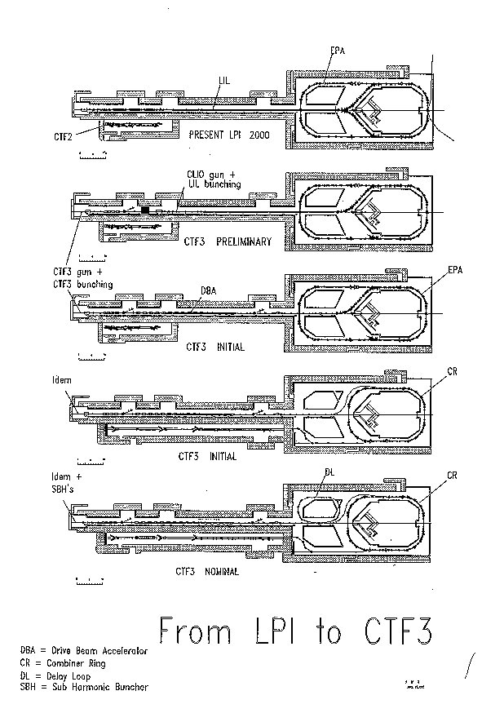

CTF3 preliminary stage

- Thermionic gun (= CLIO gun)

Cathode 0.5 cm² (2 cm²)
Current 1 - 2 A
Should be adapted to the existing LIL plug-in

- Gun pulser 7 pulses spaced by 420 ns

- LIL Bunching system

PB B 4 MeV 0.3 A

- LIL Matching system

SNF QF1 QD2 QF3

- Beam instrumentation

CTF3 Injector Preliminary stage

Parameters expected at injector exit

New CLIO gun + present LIL bunching system

May 2000

Parameters | Unit | Preliminary
Beam energy | MeV | 4
Beam pulse length | μs | 2.53
RF pulse length | μs | ≥ 3.8
Beam current | A | 0.3 - 0.6
Gun current | A | 1 - 2
Useful charge per pulse | nC | 10
Total charge per pulse | nC | 14
Useful bunches per pulse |  | 100
Total bunches/pulse |  | 140
Charge per bunch | nC | 0.1 - 0.2
Bunch spacing | m | 0.1
Bunch length (FWHM) | ps | 14
Bunch length (rms) | mm | 1.8
Normalized emittance (rms) | mm-mrad | 50
Energy spread  (single bunch rms) | MeV | < 0. 5
Charge variation bunch to bunch | % | < 20
Beam repetition rate | Hz | 50
RF repetition rate | Hz | 100
RF fundamental frequency | GHz | 2.99855
Number of klystron 35 MW |  | 1
RF peak power for injector | MW | 30

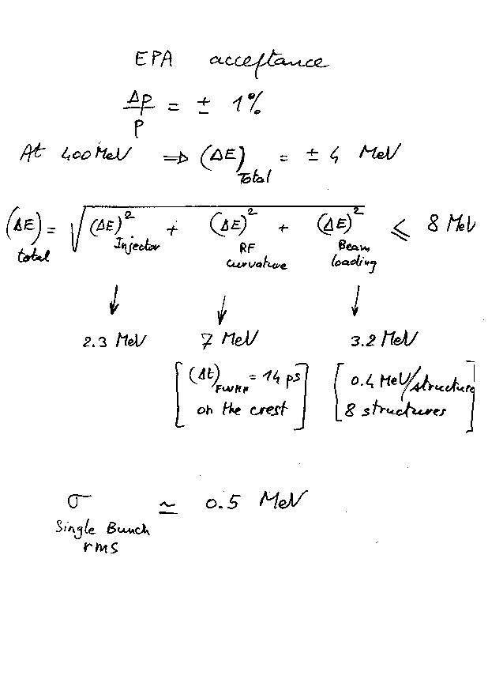

Parameters for the CLIO gun used for the CTF3 Preliminary stage

Parameters | Unit | Preliminary
Voltage (for beam) | kV | 90
Voltage (for conditioning) | kV | 100
Length of pulse train | μs | 2.6
Gun current | A | 1 - 2
Rise/Fall time | ns | ≤ 2
Pulse spacing jitter (420 ns) | ns | ≤ ± 0.5
Voltage stability ΔV/V | % | 0.1
Emittance (norm., edges) | mm.mrad | ≤ 15
Beam repetition rate | Hz | 50

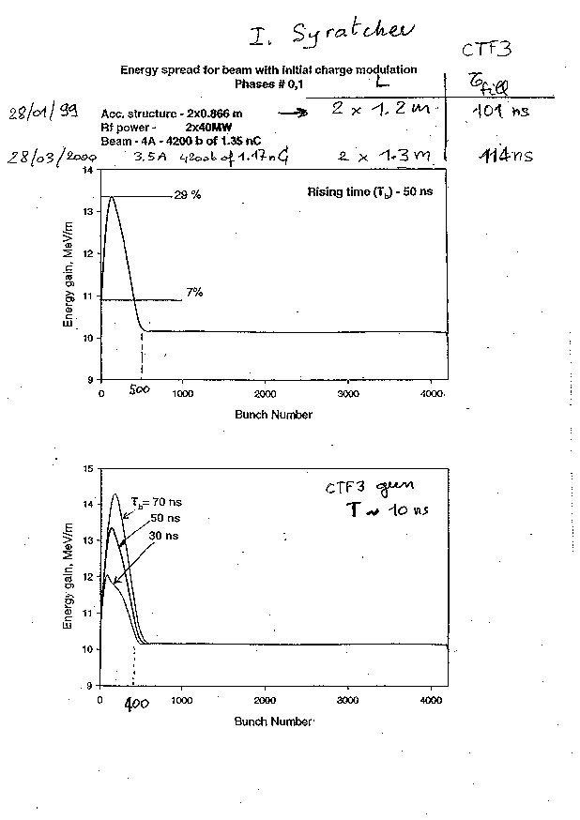

CTF3 Injector Initial and Nominal stages

Target parameters at injector exit

May 2000

Parameters | Unit | Initial | Nominal
Beam energy | MeV | ≈ 26 | ≈ 26
Beam pulse length | μs | 1.54 | 1.54
RF pulse length | μs | ≥ 1.6 | ≥ 1.6
Beam current | A | 3.5 | 3.5
Gun current | A | 7 | 7
Useful charge per pulse | nC | 4893 | 4893
Total charge per pulse | nC | 5382 | 5382
Useful bunches per pulse |  | 4200 | 2100
Total bunches/pulse |  | 4620 | 2310
Charge per bunch | nC | 1.17 | 2.33
Allowed charge in satellite | % |  | <5
Bunch spacing | m | 0.1 | 0.2
Bunch length (FWHM) | ps | < 12 | < 12
Bunch length (rms) | mm | < 1.5 | < 1.5
Normalized emittance (rms) | mm-mrad | < 100 | < 100
Energy spread  (single bunch rms) | MeV | < 0.5 | < 0.5
Energy spread (total on flat top incl. Beam loading) | MeV | < 1 | < 1
Charge variation bunch to bunch  (High Frequency: f >> 1/ τ_{f} ) | % | < 2 | < 2
Charge flatness total on flat top  (Low Frequency: f ≈ 1/ τ_{f}) | % | < 0.1 | < 0.1
Beam repetition rate | Hz | 5 | 5
RF repetition rate | Hz | 30 | 30
RF fundamental frequency | GHz | 2.99855 | 2.99855
Number of klystrons 45 MW |  | 2 | 2
RF peak power (MDK decoupled) | MW | 124 (*) | 124 (*)
RF peak power (MDK coupled) | MW | 168 (**) | 168 (**)
Accelerator structure length | m | 1 | 1
(*) 1 x 40 MW (without LIPS on Buncher) + 2.1 x 40 MW (with LIPS on the 2 ACS)
(**) 2 x 40 MW x 2.1 = 168 MW (with LIPS on the Buncher and on 2 ACS)

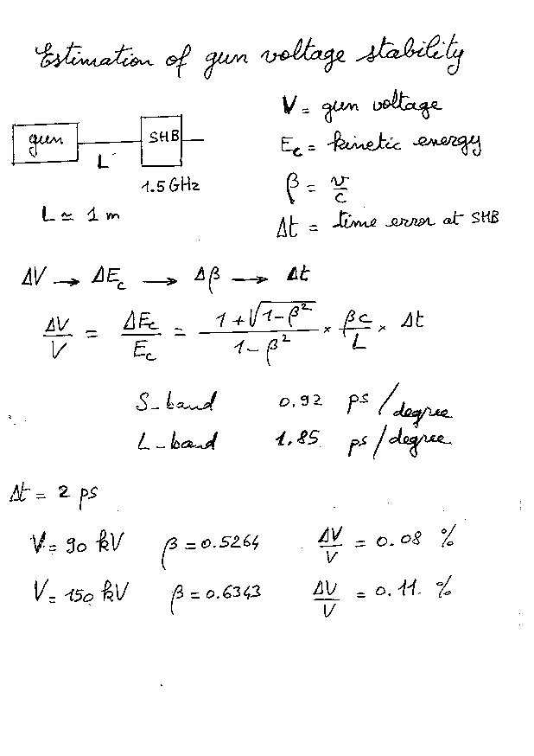

Parameters for the CTF3 gun used for the Initial and Nominal stages

Parameters | Unit | Initial and Nominal
Voltage | kV | 150 (*)
Pulse length | μs | 1.6
Gun current | A | 7
Charge per pulse | μC | 11
Rise/ Fall time | ns | ≤ 10
Voltage stability ΔV/V | % | ≤ 0.1
Charge flatness on flat top | % | ≤ 0.1
Emittance (norm., edges) | mm.mrad | ≤ 10
Repetition rate | Hz | 5

(*) Preliminary value which may be reduced in the course of the injector design study between 90 kV and 150 kV.

Parameters for CLIC / CTF3 Laser
October 1999

Linear accelerator | CTF-3 | CLIC 3 TeV
Repetition rate | 5 Hz | 100 Hz
Macro-pulse duration / Linac | 1.4 μs | 91.6 μs
Micro-pulse number / Linac | 2145 | 42944
Distance between pulses | 20 cm (667 ps) | 64 cm (2.13 ns)
Total train number / Linac | 11 | 704
Pulse number / Train | 195 | 122
Pulse width (FWHH) | 10 ps | 24 ps
Charge / pulse | 2.4 nC | 16 nC
Total charge / Linac | 5.2 μC | 690 μC
Charge stability | < 0.5 % rms | 0.1 % rms
Photo cathode | Cs₂Te | Cs₂Te
Photo-cathode quantum efficiency @ λ ≤ 270 nm | 1.5 % | 1.5 %
Laser energy stability (UV) | 0.5 % rms | < 0.5 % rms
Laser / RF pulse synchronisation | < 1 ps | < 1 ps
Output wavelength | < 270 nm | < 270 nm
UV Laser energy / μpulse | 0.76 μJ | 5 μJ
Total Laser energy on the PC | 1.6 mJ | 215 mJ
Total efficiency from IR to UV at the photo cathode | 5 % | 5 %
IR Laser energy / Linac | 32 mJ | 4.3 J
Linac number | 1 | 2
Total IR laser energy | 32 mJ | 8.6 J
Laser Average Power | 0.15 W | 860 W

Planning indicative for the CTF3 Injector

Year 2000

April 2000 Send CLIO gun specifications to LAL
(cahier des charges)

May 2000: Decide voltage for CTF3 gun
Send new CTF3 gun specifications to LAL
(cahier des charges)

December 2000:
Complete beam dynamics design studies of the injector (26 MeV) for both the Initial and Nominal stages.
Complete beam loading analysis.
Produce Superfish files defining basic geometry of the Pre-Buncher (PB) and the Buncher (B).
Send PB specification for the Initial stage to LAL
(cahier des charges).

Year 2001

January 2001: Detail RF design and fabrication drawings for Buncher (CERN).
Start construction of solenoids.
Design and specification of MDK 1.5 GHz for SHB.
Start modifications of LIL front-end for CTF3
Preliminary phase

April 2001: End of LAL tests of CLIO gun.

May 2001: CLIO gun available at CERN

June 2001: Install CLIO gun in LIL
Start commissioning of injector
Start solenoid measurements

Year 2002

January 2002: CTF3 gun available at CERN
Start design of SHB
Construction of MDK 1.5 GHz
Test and commissioning of injector

Year 2003

Construction of SHB's and tests at CERN

Year 2004

January 2004: CTF3 Nominal stage
Installation

More details later on…..

