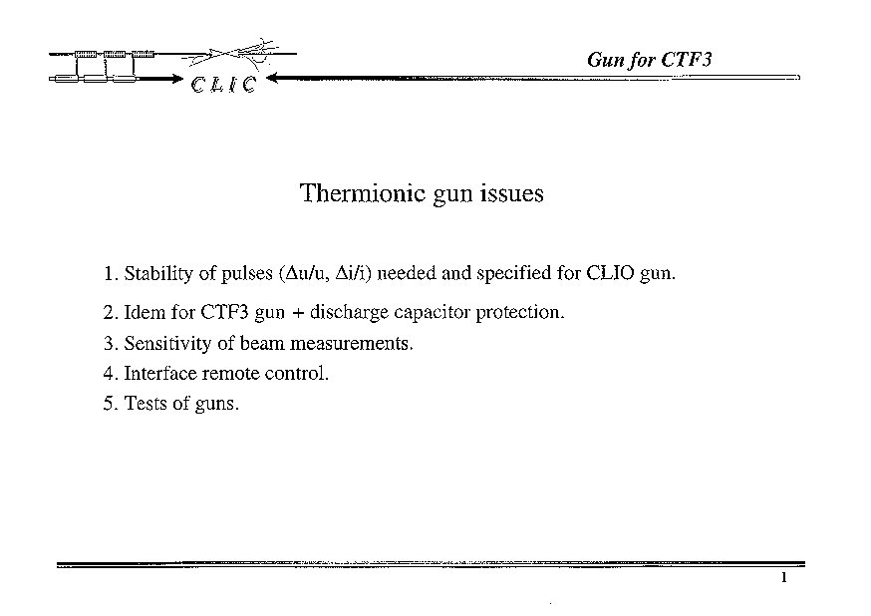
Clio gun

I measure

Rp Ti Rk Triode
H.V.

Rb
Cl Rg Cg

U measure

HV = 90kV Cl = 2 nF Rp = 1kΩ Rk = 50Ω Rg = 45 kΩ/2A Cg = 30pF

Ti => Curent transformer 1V/amp 200MHz

Rb => HV voltage divider 0.01% DC 0.5% AC up to 10MHz

ΔU/U = 7,8.10⁻⁴ for 2 Amps

W = 8,1 J

I_{HV} = 3,8 mA

P_{HV} = 340 W

CTF3 gun

I measure

Rp Ti Rk Triode
H.V

Rb
Rg Cg

U measure

HV=90/150 kV Rp= Rk= Rg=12/20 kΩ/7A Cg=120/80 nF

Ti => Curent transformer 1V/amp 200MHz

Rb => HV voltage divider 0.01% DC 0.5% AC up to 10MHz

ΔU/U = 1.10⁻³ for 7 Amps

HV = 90kV HV = 150kV

W = 486 J W = 900 J

I_{HV} = 23 mA I_{HV} = 23 mA

P_{HV} = 2 k W P_{HV} = 3,4 k W

Interface remote control

Manual Control

GUN

Control
Interface

VME
Interface
Electronics

. Control interface has to manage:
.Specificities of the gun
. Remote control
. Communication with VME

. Hardware:
. G64, CPU, in/out analog and logical cards
. Integrated Automation (Simatic)

Tests of Guns

Tests at LAL:

GUN

Manual Control

Electronics

. Electronics tests.
. H.V. Tests
. Conditionning
. Beam tests (shape, stability, accuracy)
. Behavior of electronics during voltage break downs

Tests at CERN:

Control
Interface

VME
Interface
Gun simulator

. Tests of interface and control

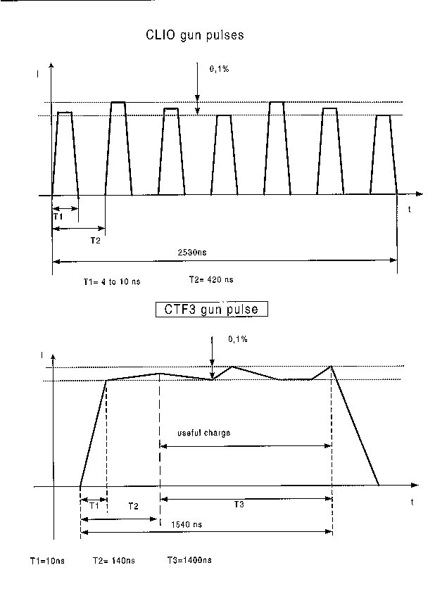

Sensitivity of beam measurements

Beam monitors :

. ECM (Electrode Capacitive de Mesure) => 50μV/mA

Z=50Ω for Clio gun

Z=1MΩ for CTF3 gun (has to be tested)

. WCM (Wall Current Monitor) => 2,8V/A

Z=50Ω
Low frequency cut off (f-3dB) = 100KHz

High frequency cut off (f-3dB) = 1,5GHz ( 280ps FWHM)

